Intents and Intent Filters

An [Intent](https://developer.android.com/reference/android/content/Intent.html) is a messaging object you can use to request an action from another [app component](https://developer.android.com/guide/components/fundamentals.html#Components). Although intents facilitate communication between components in several ways, there are three fundamental use cases:

* **Starting an activity**

An [Activity](https://developer.android.com/reference/android/app/Activity.html) represents a single screen in an app. You can start a new instance of an [Activity](https://developer.android.com/reference/android/app/Activity.html) by passing an [Intent](https://developer.android.com/reference/android/content/Intent.html) to [startActivity()](https://developer.android.com/reference/android/content/Context.html" \l "startActivity(android.content.Intent)). The [Intent](https://developer.android.com/reference/android/content/Intent.html) describes the activity to start and carries any necessary data.

* **Starting a service**

A [Service](https://developer.android.com/reference/android/app/Service.html) is a component that performs operations in the background without a user interface. With Android 5.0 (API level 21) and later, you can start a service with [JobScheduler](https://developer.android.com/reference/android/app/job/JobScheduler.html). also you can start it by passing an [Intent](https://developer.android.com/reference/android/content/Intent.html) to [startService()](https://developer.android.com/reference/android/content/Context.html" \l "startService(android.content.Intent)).

The [Intent](https://developer.android.com/reference/android/content/Intent.html) describes the service to start and carries any necessary data.

* **Delivering a broadcast**

A broadcast is a message that any app can receive. The system delivers various broadcasts for system events, such as when the system boots up or the device starts charging. You can deliver a broadcast to other apps by passing an [Intent](https://developer.android.com/reference/android/content/Intent.html) to [sendBroadcast()](https://developer.android.com/reference/android/content/Context.html" \l "sendBroadcast(android.content.Intent)) or [sendOrderedBroadcast()](https://developer.android.com/reference/android/content/Context.html" \l "sendOrderedBroadcast(android.content.Intent,%20java.lang.String)).

## Intent types

There are two types of intents:

* **Explicit intents** specify which application will satisfy the intent, by supplying either the target app's package name or a fully-qualified component class name. For example, you might start a new activity within your app in response to a user action, or start a service to download a file in the background.
* **Implicit intents** do not name a specific component, but instead declare a general action to perform, which allows a component from another app to handle it. For example, if you want to show the user a location on a map, open a web page etc.

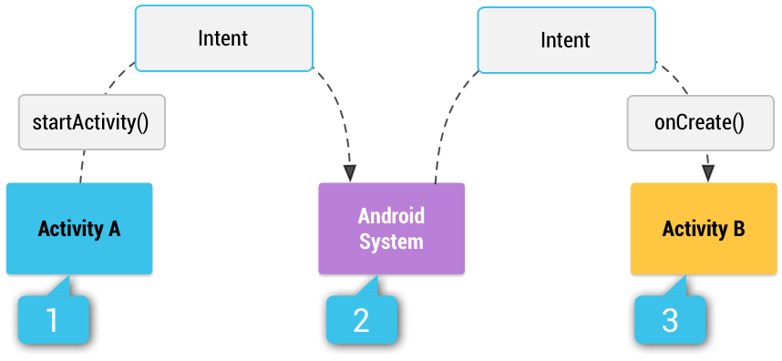

**Figure 1.** How an implicit intent is delivered through the system to start another activity:

**[1]** Activity A creates an[Intent](https://developer.android.com/reference/android/content/Intent.html) with an **action description** and passes it to [startActivity()](https://developer.android.com/reference/android/content/Context.html" \l "startActivity(android.content.Intent)).

**[2]** The Android System searches all apps for an intent filter that matches the intent. When a match is found,

**[3]** the system starts the matching activity (Activity B) by invoking its [onCreate()](https://developer.android.com/reference/android/app/Activity.html" \l "onCreate(android.os.Bundle)) method and passing it the [Intent](https://developer.android.com/reference/android/content/Intent.html).

## Building an intent

An [Intent](https://developer.android.com/reference/android/content/Intent.html) object carries information that the Android system uses to determine

* which component to start (such as the exact component name or component category that should receive the intent),
* plus information that the recipient component uses in order to properly perform the action (such as the action to take and the data to act upon).

The primary information contained in an [Intent](https://developer.android.com/reference/android/content/Intent.html) is the following:

1. **Component name**

The name of the component to start. This is optional, but it's the critical piece

- explicit, meaning that the intent should be delivered only to the app component defined by the component name.

-Without a component name, the intent is implicit

1. **Action**

A string that specifies the generic action to perform (such as *view* or *pick*).

[ACTION_VIEW](https://developer.android.com/reference/android/content/Intent.html#ACTION_VIEW) photo to view in a gallery app, or an address to view in a map

[ACTION_SEND](https://developer.android.com/reference/android/content/Intent.html#ACTION_SEND) share intent, you should use this in an intent with [startActivity()](https://developer.android.com/reference/android/content/Context.html" \l "startActivity(android.content.Intent)) when you have some data that the user can share through another app, such as an email app

1. **Data**

The URI (a [Uri](https://developer.android.com/reference/android/net/Uri.html) object) that references the data to be acted on and/or the MIME type of that data. The type of data supplied is generally dictated by the intent's action.

1. **Category**

A string containing additional information about the kind of component that should handle the intent. Any number of category descriptions can be placed in an intent, but most intents do not require a category. Here are some common categories:

[CATEGORY_BROWSABLE](https://developer.android.com/reference/android/content/Intent.html#CATEGORY_BROWSABLE)

[CATEGORY_LAUNCHER](https://developer.android.com/reference/android/content/Intent.html#CATEGORY_LAUNCHER)

1. **Extras**

Key-value pairs that carry additional information required to accomplish the requested action.

You can add extra data with various [putExtra()](https://developer.android.com/reference/android/content/Intent.html" \l "putExtra(java.lang.String,%20android.os.Bundle)) methods, each accepting two parameters: the key name and the value. You can also create a [Bundle](https://developer.android.com/reference/android/os/Bundle.html) object with all the extra data, then insert the [Bundle](https://developer.android.com/reference/android/os/Bundle.html) in the [Intent](https://developer.android.com/reference/android/content/Intent.html) with [putExtras()](https://developer.android.com/reference/android/content/Intent.html" \l "putExtras(android.content.Intent)).

1. **Flags**

Flags are defined in the [Intent](https://developer.android.com/reference/android/content/Intent.html) class that function as metadata for the intent. The flags may instruct the Android system how to launch an activity (for example, which [task](https://developer.android.com/guide/components/tasks-and-back-stack.html) the activity should belong to) and how to treat it after it's launched (for example, whether it belongs in the list of recent activities).